Sheet Metal With 2 mm thickness

RAW MATERIAL PREPARATION

Material Procurement
  - 2 mm thick metal sheet (pre-polished or raw)

Initial Sheet Cutting (Blank Size)
  - Method: Water Jet Cutting
  - Why: Cold cutting, no thermal distortion, high precision for sheet metal.
  - Use: Cut the outer dimensions (base size of the sheet).

PROFILE & HOLE CUTTING

Outer Profile Contours
  - Method: Water Jet Cutting or Wire EDM (for tighter tolerance)
  - Use: Shapes, notches, or rounded corners.

Hole Cutting
  - Method:
    - Wire EDM for precise holes
    - Laser Drilling or Plasma for rough holes (if allowed in "non-conventional")
  - Use: Ø6 mm, Ø5.65 mm, or any slotted holes seen in drawing.
SURFACE MODIFICATION (OPTIONAL)
- Edge Smoothing / Deburring
  - Method: Abrasive Flow Machining or Vibratory Finishing
  - Use: Smoothen edges post-cutting.
- Surface Texturing or Polishing
  - Method: Electrochemical Polishing
  - Use: For stainless steel parts to improve corrosion resistance and appearance.

FINAL STEPS

Cleaning
  - Method: Ultrasonic Cleaning
  - Use: Remove micro-particles, water jet residue, or polishing fluid.

Inspection
  - Tool: CMM or Laser Scanner
  - Use: Dimensional checks for tolerances, hole position, and flatness.

SUMMARY TABLE
Step | Method | Equipment
Raw Sheet Cut | Water Jet | CNC Water Jet Cutter
Hole and Slot Machining | Wire EDM / Laser Drilling | Wire EDM / Laser Driller
Profile Cutting | Water Jet / EDM | CNC Water Jet or EDM
Edge Finishing | Abrasive Flow / Vibratory | Deburring Equipment
Surface Polishing | Electrochemical Polishing | Electro-polisher
Cleaning | Ultrasonic Cleaning | Ultrasonic Cleaner
Dimensional Inspection | CMM / Scanner | Coordinate Measuring Machine

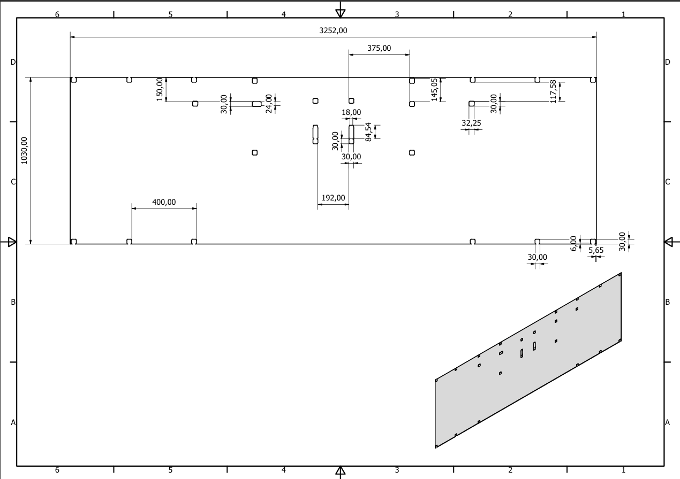
Base
Figure 1 Base Sheet Working Drawing

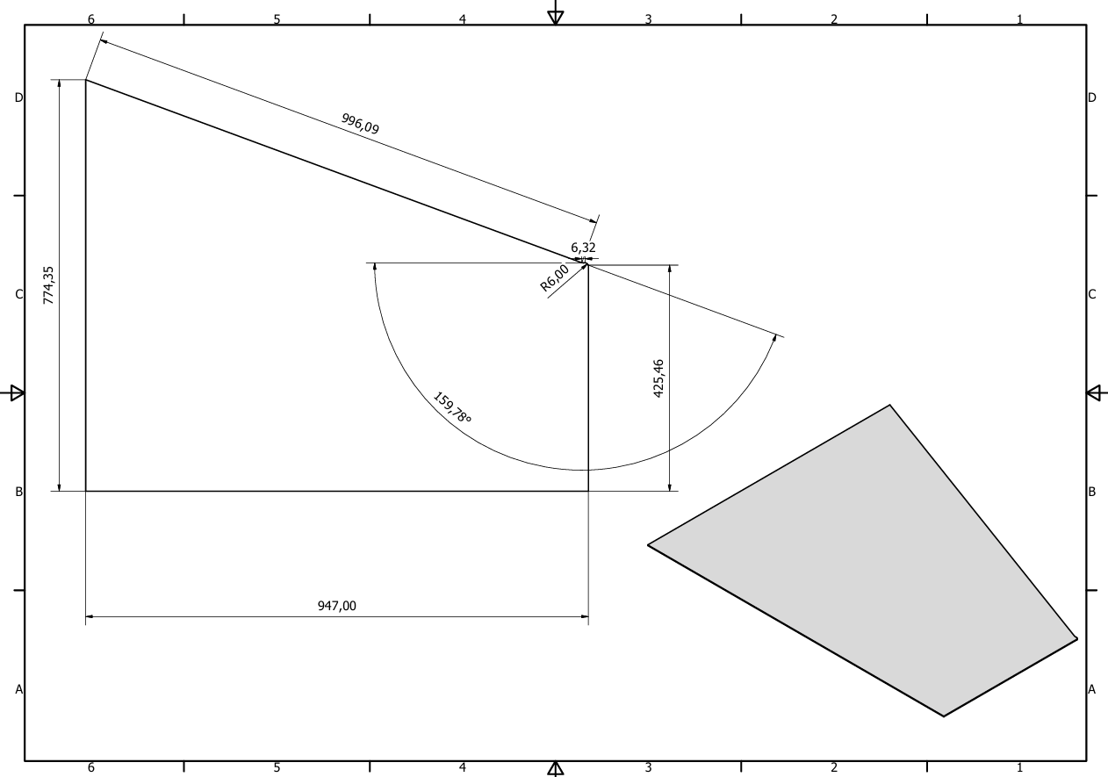
Side

Figure 2 Side Sheet Working Drawing

Inclined 1
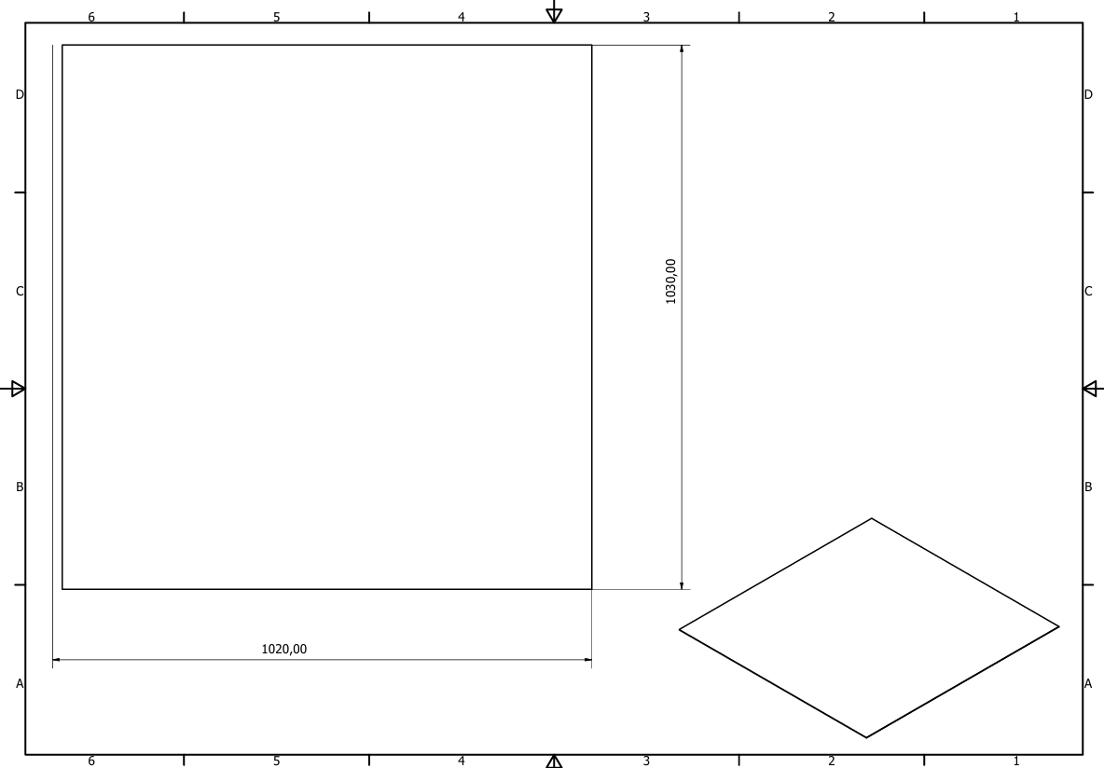

Figure 3 Inclined 1 Sheet Working Drawing

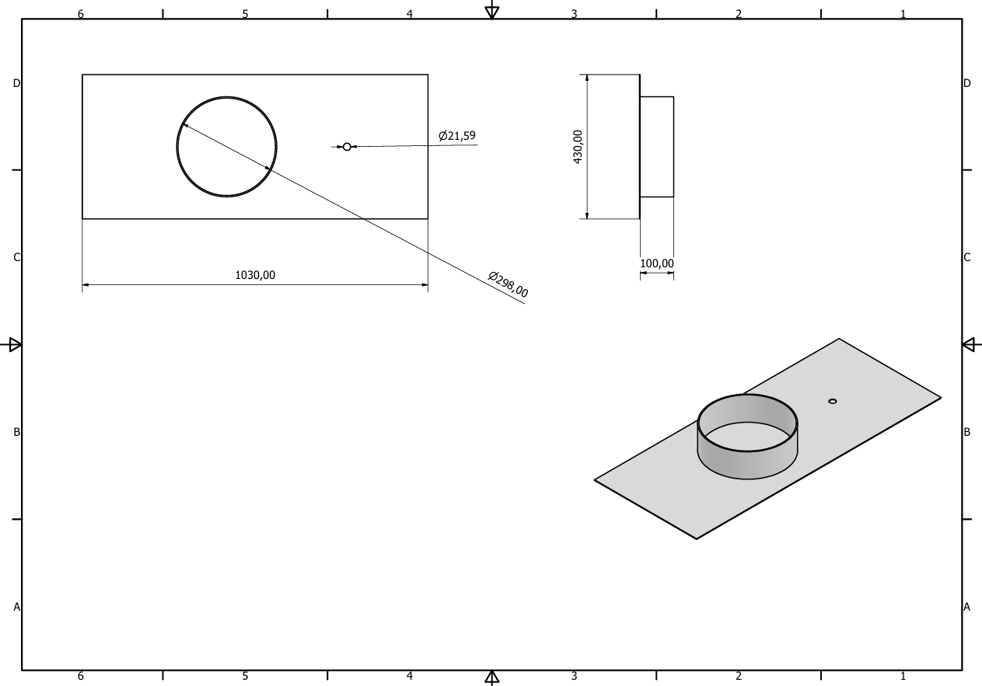
Mid Base 1
Figure 4 Mid Base 1 Sheet Working Drawing

Mid Base 2
Figure 5 Mid Base 2 Sheet Working Drawing
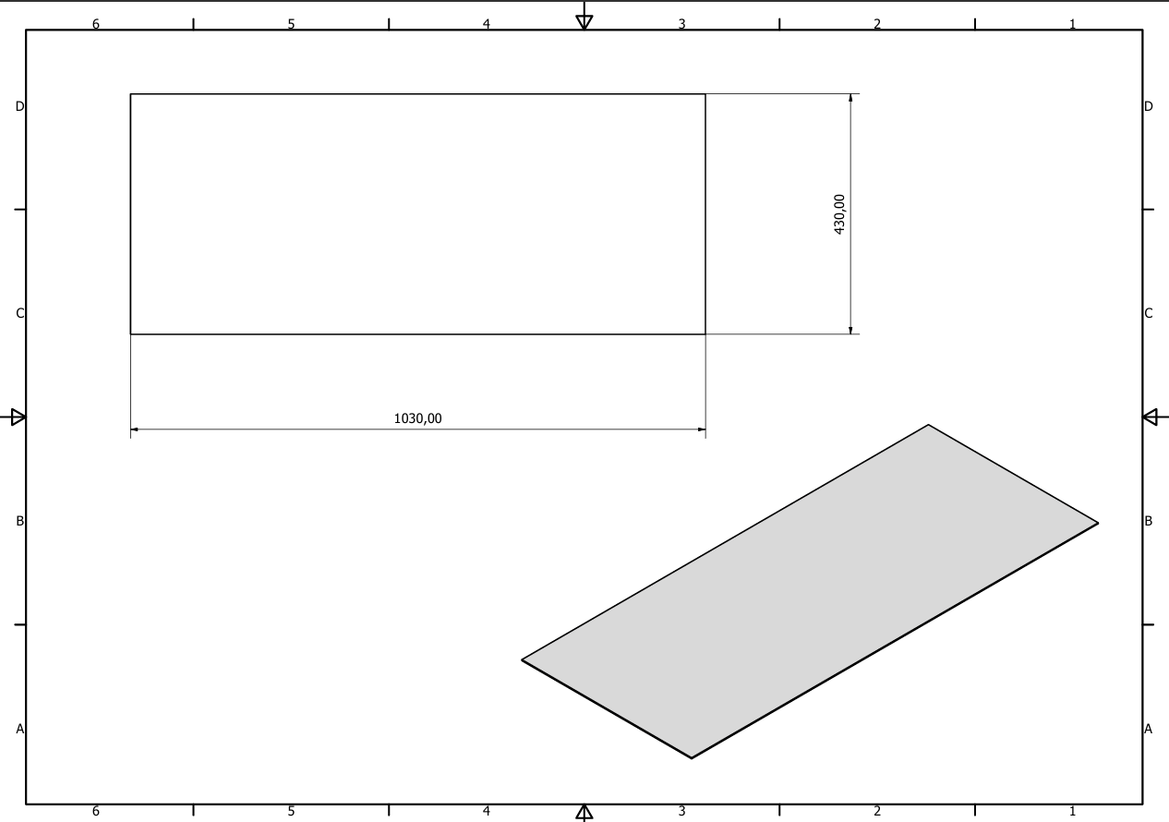

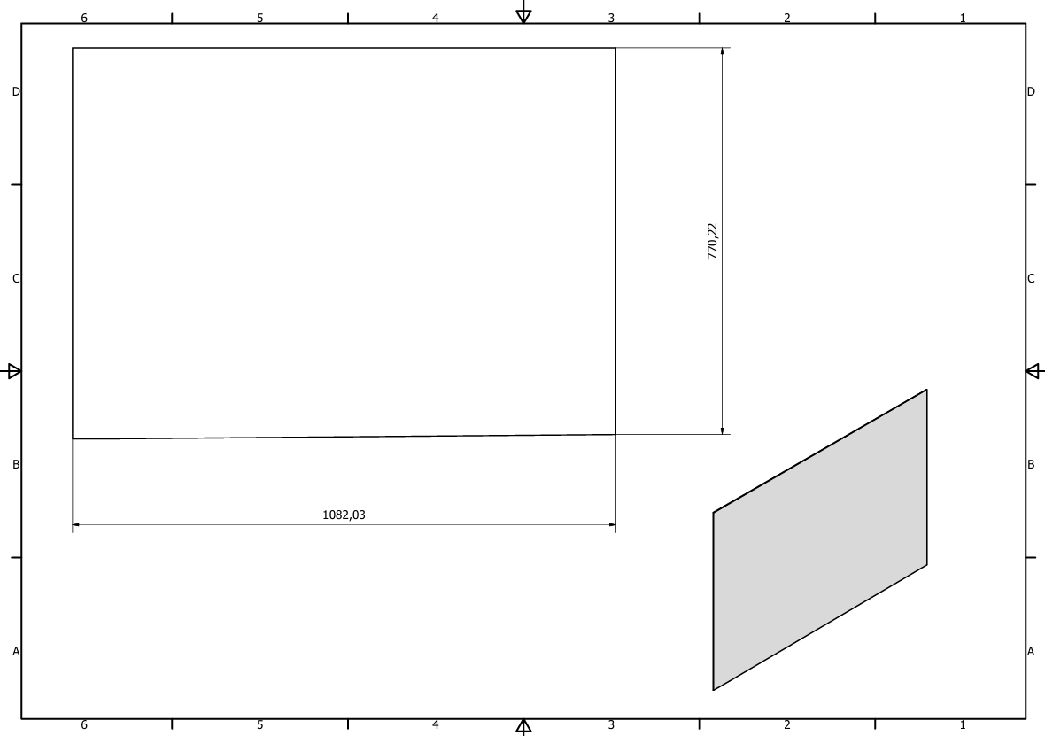
Inclined 2

Figure 6 Inclined 2 Sheet Working Drawing

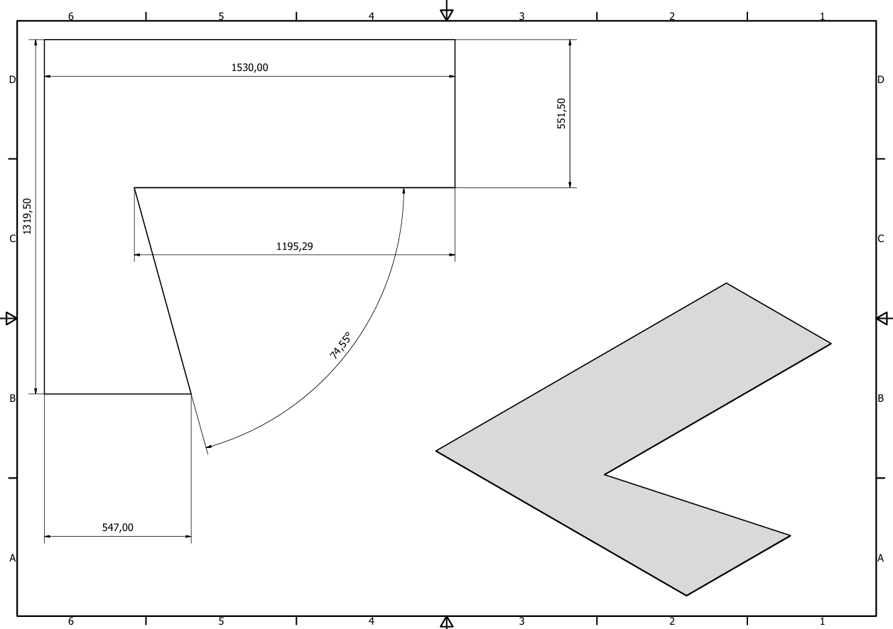
Top
Figure 7 Top Sheet Working Drawing

Top Base
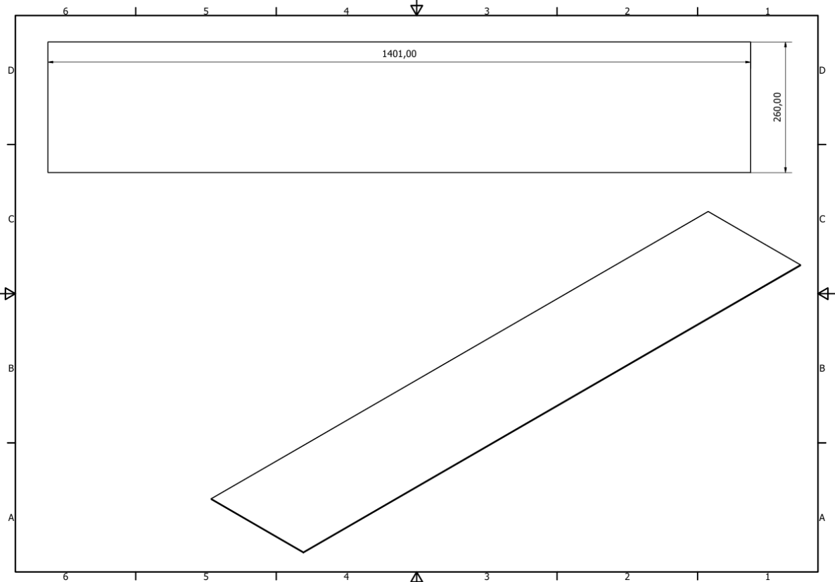
Figure 8 Top Base Sheet Working Drawing

Triangle
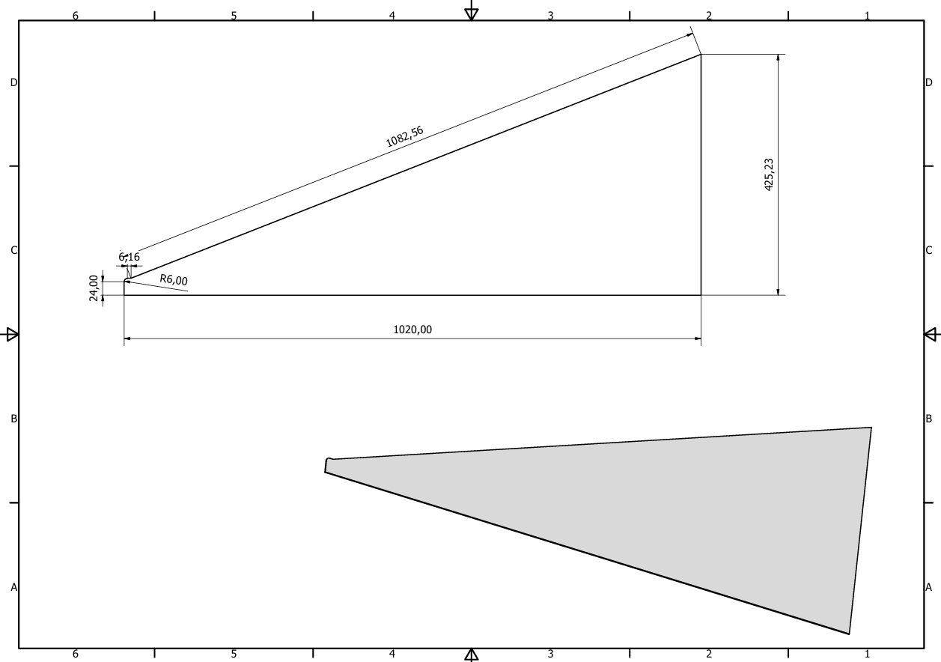
Figure 9 Triangle Sheet Working Drawing

Vertical
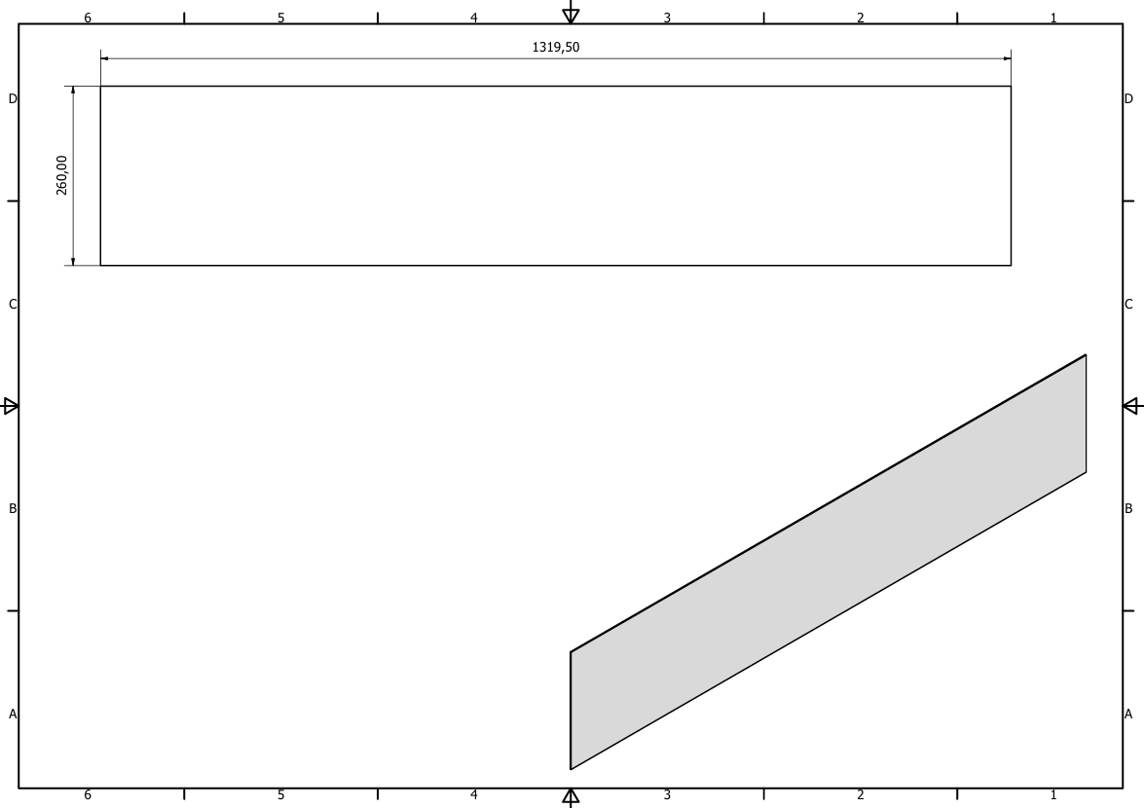
Figure 10 Vertical Sheet Working Drawing

